CURRENT RESEARCH PROJECTS

1) Characterization on ‘Ancillary’ proteins involved in modulating photosynthesis

By employing Dynamic Environmental Phenometrics Imagers (DEPI) (developed in the Kramer Lab), the Emerging Phenotype (EP) group has identified numerous genes with ‘ancillary’ functions that are conditionally essential for photosynthesis when plants are exposed to fluctuating environmental conditions. Currently, we are actively engaged in determining the function of many of these genes and their mechanism of action by applying a multi-step strategy that involves using an assortment of approaches such as: 1) Plant Phenometric Arrays; 2) Various Computational Approaches; and 3) Numerous Biophysical and Biochemical Techniques. Our long-term goal is to characterize ALL ‘ancillary’ proteins that are involved in the regulation and modulation of photosynthesis. Specifically, we propose to characterize unique ancillary proteins that are involved in either the transcriptional, photochemical or environmental regulation of photosynthesis under fluctuating light conditions (See Figure 1). To this end, we have initially focused our efforts on ancillary proteins that are targeted to the thylakoids and thus may play a critical role in regulating photosynthesis under various environmental conditions. For instance, many of ‘ancillary’ proteins (APs) that have been identified by DEPI are predicted to be localized to the chloroplasts . As a consequence, we have used our well-established in vitro chloroplast import assay to confirm the targeting of these APs to the chloroplasts and have further determined their subcellular localization (i.e. stroma, thylakoid, envelope membrane) within chloroplasts. We have also investigated the topology of several unique APs that have been confirmed to be targeted to the thylakoid membrane. Finally, future lines of research will entail identifying additional proteins that interact with various APs and thus modulate these APs as they regulate the photosynthetic process under fluctuating environmental conditions. We anticipate that the information arising from our multifaceted approach will contribute to our understanding of how various APs affect individual photosynthetic complexes as well as how they regulate and control the overall photosynthetic process.
Preliminary results from Phenometric analysis have shown that many of these APs have functions important for photosynthesis efficiency and robustness. Consequently, these promising results raise many fundamental questions such as:
- How do these ancillary proteins control/modulate photosynthetic responses?
- What are their mechanistic bases?
- How are they critical for photosynthetic robustness and efficiency?
Ultimately, these questions need to be answered at the biochemical, biophysical and physiological levels.

Figure 1. Overview of the various roles that ‘ancillary’ proteins identified by DEPI chamber analysis may have on the regulation and modulation of photosynthesis. Currently, we are focused on characterizing ancillary proteins that are involved in: 1) transcriptional regulation; 2) photochemical regulation and 3) environmental regulation of the biogenesis and turnover of the various photosynthetic complexes.

2) The Biogenesis and Assembly of Photosynthetic Complexes

Chloroplasts, unlike mitochondria or peroxisomes, contain an additional internal membrane system known as the thylakoid membrane. The thylakoid membranes are the location for the light reactions of photosynthesis. Indeed, photosynthesis is the defining event commonly associated with plant life: it converts light energy, captured by pigment-containing light-harvesting antennae, into chemical energy that ultimately sustains all life on our planet. The thylakoid membranes contain the four major photosynthetic complexes: photosystem I (PSI), photosystem II (PSII), the cytochrome b₆f complex, and the ATP synthase complex. Together, these complexes constitute approximately 60 different integral membrane proteins of which nearly half are nuclear-encoded. Consequently, biogenesis of the photosynthetic apparatus requires the coordinated synthesis, targeting, and subsequent assembly of both nuclear- and chloroplastic-encoded proteins to form functional photosynthetic complexes (Figure 2). In addition, the maintenance of the photosynthetic apparatus requires the import of nuclear-encoded, thylakoidal proteins that are involved in the repair of PSII during periods of photoinhibition. Thus, a large number of proteins that play a critical role in either the biogenesis or maintenance of thylakoids must first cross the envelope membrane before being directed to either the thylakoid membrane or lumen. We are focusing on the specific question: How are integral thylakoid membrane proteins translocated across the envelope membrane unhindered as they travel to their final destination, the thylakoid membrane?
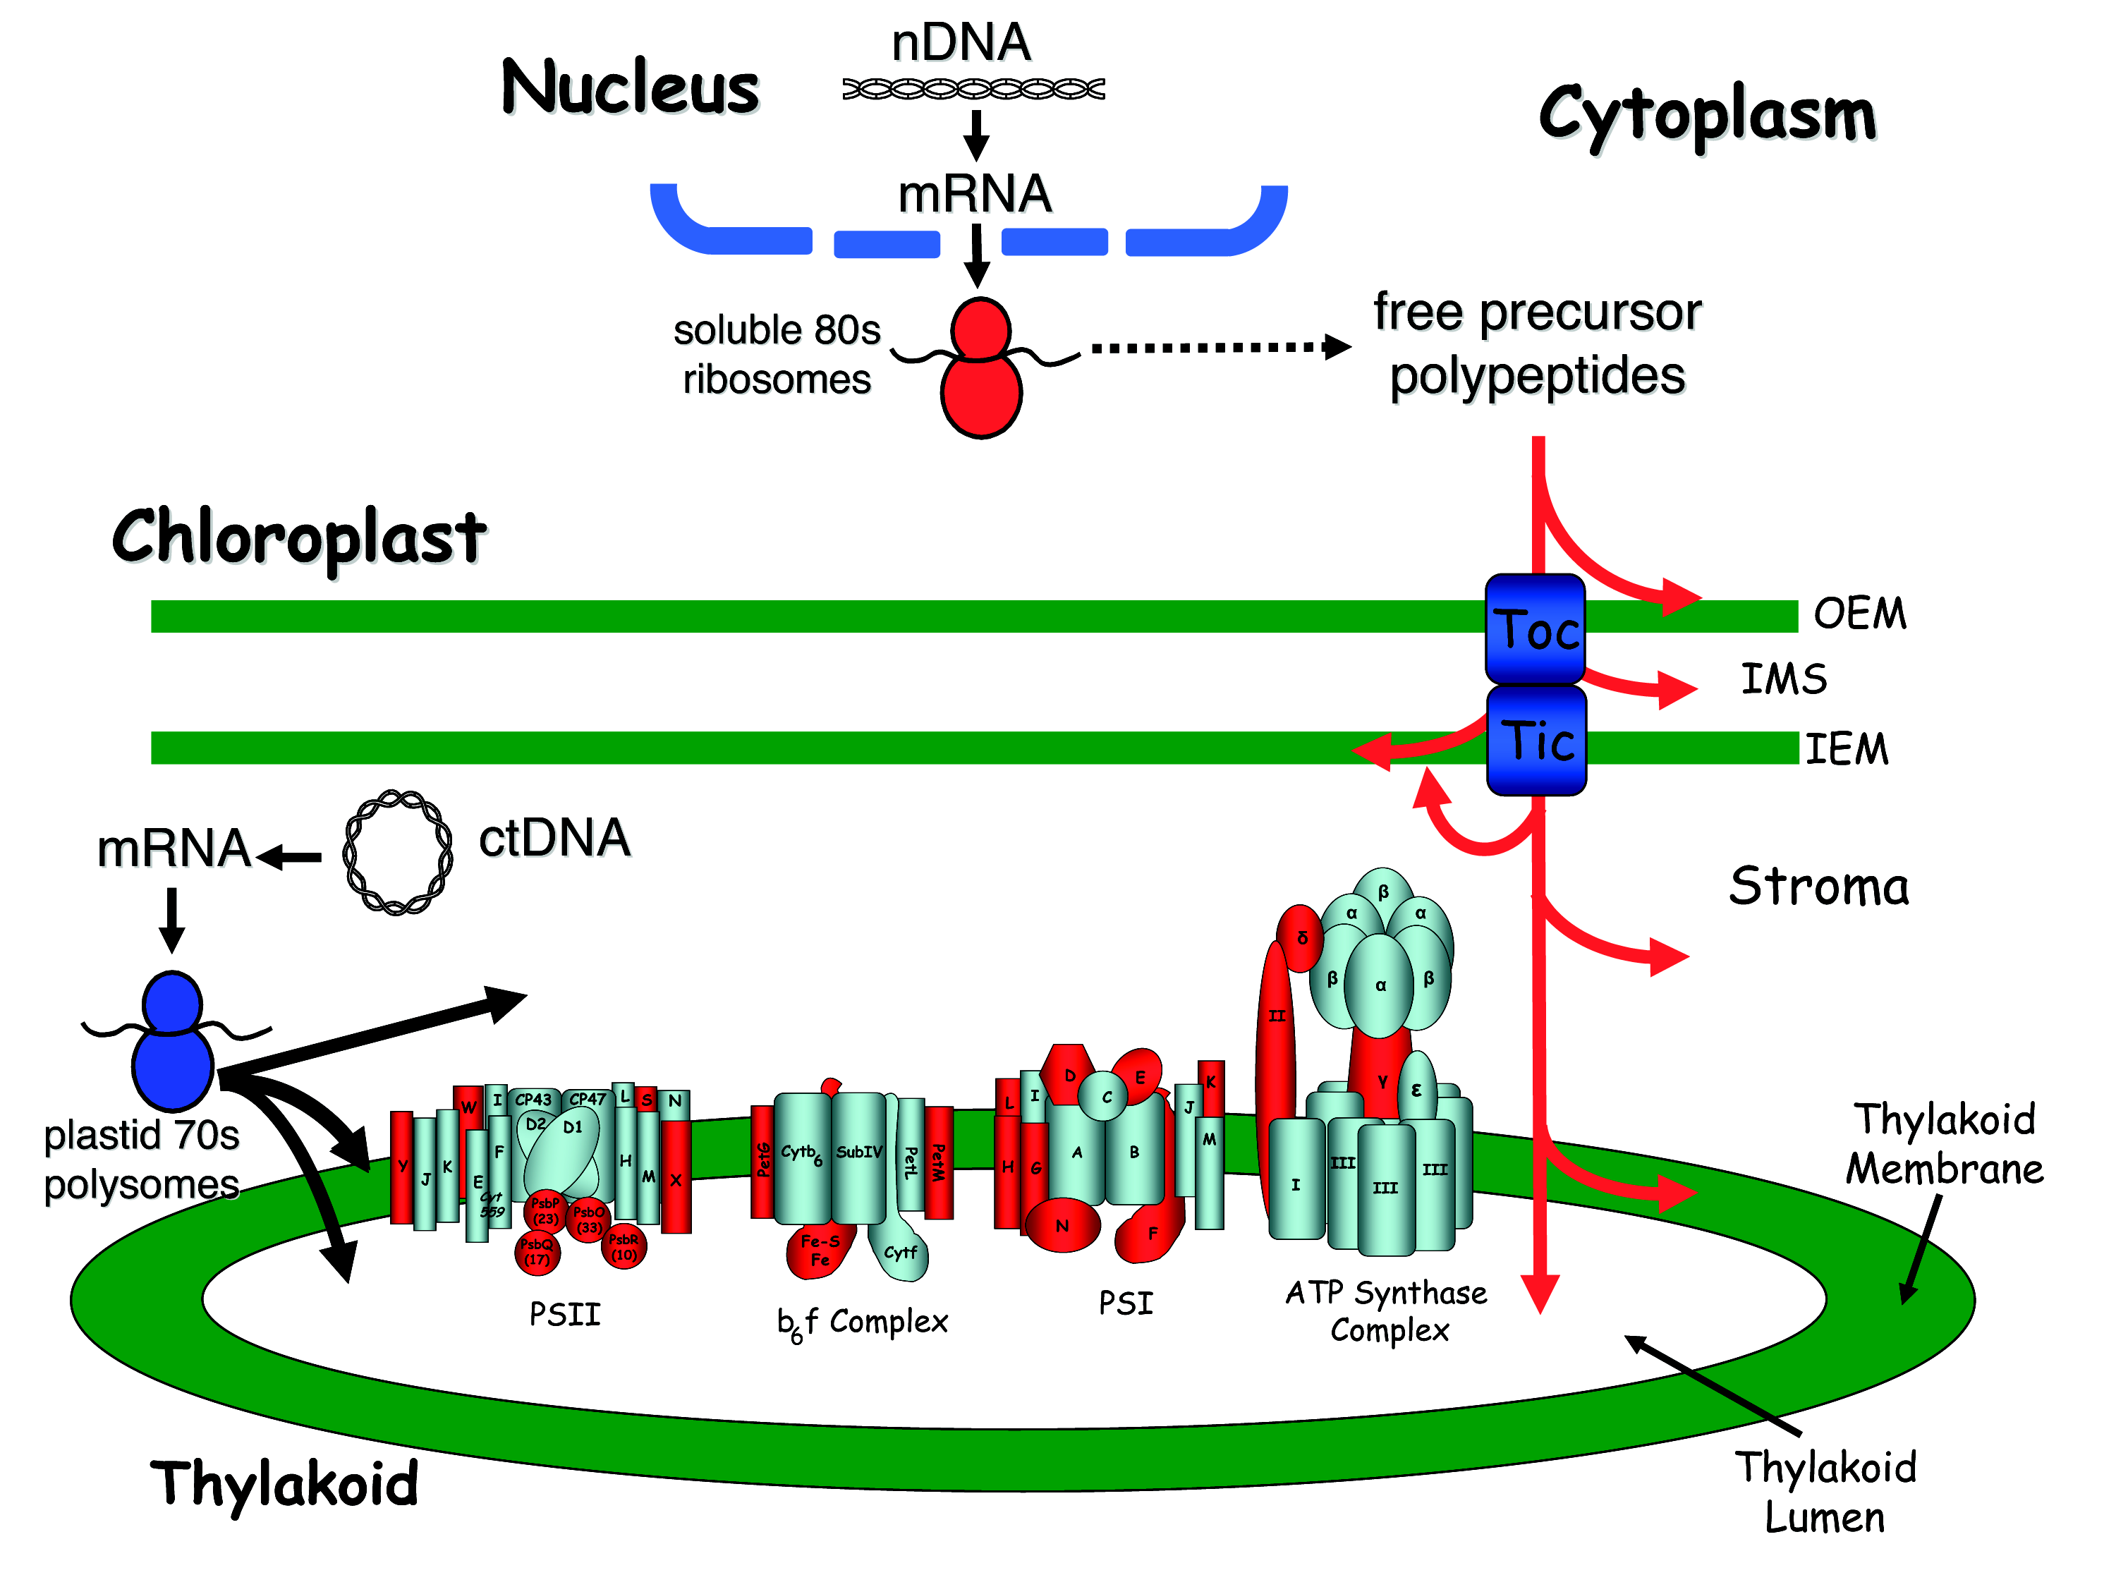
Figure 2. Overview of protein import into chloroplasts. Nuclear-encoded proteins can be targeted to various subcompartments within a chloroplast, as indicated by the mutli-headed red arrow. Nuclear-encoded photosynthetic complex proteins must first cross the envelope membrane using the Toc/Tic complex (in blue) prior to their targeting and insertion into the thylakoid membrane. Nuclear-encoded photosynthetic proteins are shown in red and chloroplastic-encoded photosynthetic proteins are shown in aqua.

